**Project Flow**

* Users create multiple analysis graphs/charts.
* Using the analyzed chart creation of the Dashboard is done.
* Saving and Visualizing the final dashboard in the IBM Cognos Analytics.

To accomplish this, we have to complete all the activities and tasks listed below

* IBM Cloud Account
* 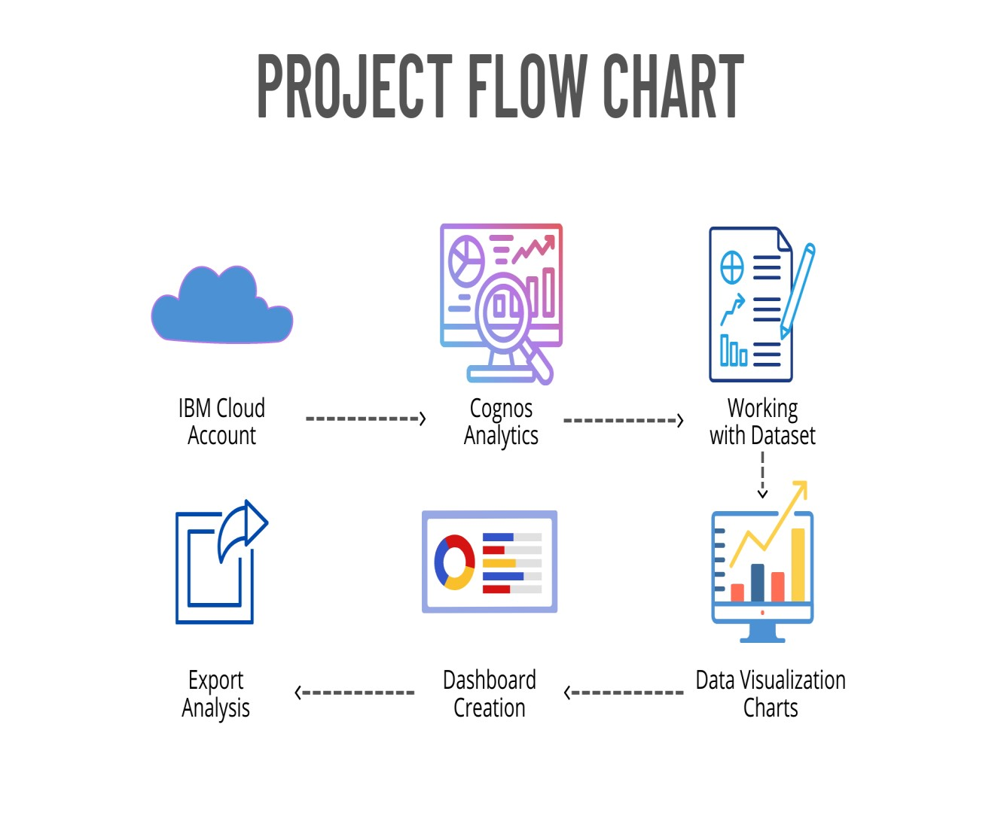Login to Cognos Analytics
* Working with the Dataset
* Understand the Dataset
* Loading the Dataset • Data visualization charts
* Seasons with average productions
* With years usage of Area and Production
* Top 10 States with most area
* State with crop production
* States with the crop production along with season (Text Table)
* Dashboard Creation
* Export the Analytics